CLASS: BE (E&TC) SUBJECT: MC
EXPT. NO: 07 DATE:

I. TITLE: PERFORMANCE PARAMETERS IN FLAT FADING CHANNEL

II. OBJECTIVE: Calculate outage probability, LCR & ADF in SISO for selection combining and MRC
(Flat Fading)

III. SOFTWARE USED: Operating System: Windows 7
Software: Java Version 6
Mozilla Firefox: version: 47.0.1
or
Compatible mode for above specification

Link to download software:
https://drive.google.com/uc?id=0B9mNeu43jUidckFYVTlnenpJRGs&export=download

IV. THEORY:
Small scale fading characterizes the fluctuation of signal (strength) over a spatial distance of fraction of wavelength. The fluctuation is also observed in both time and frequency domain at a gain location. The variation of signal (strength) at the receiver is due to random interference between the different copies of the transmitted signal. The interference is sometimes constructive and sometimes destructive. The multiple copies of the transmitted signal are generated due to scattering, reflection, and diffraction due to obstacle present in the path of radio signal between the Tx and Rx. The movement of the Tx and Rx or the obstacle cause time domain variation of the signal (strength) and the phenomenon is called as Doppler effect. Since each path of the radio wave may exhibit difference Doppler effect, its cumulative effect results in spread of the carrier/ frequency content of the signal and hence is also known as Doppler spread.

Follow the instructions given below to perform the experiments.
Step1:- Click on the button START. A page appears with a dialogue box asking for your name.

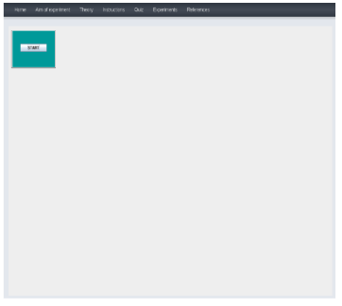

Step2: Enter your name then click OK button.

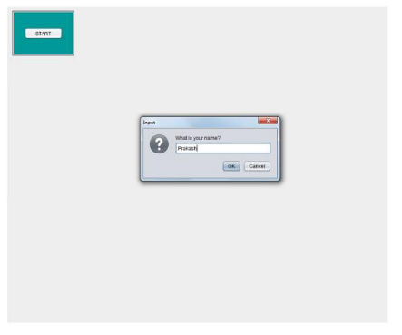
Step3: Enter the input parameters value. Then click on "RESET" Button. Observed the waveform.

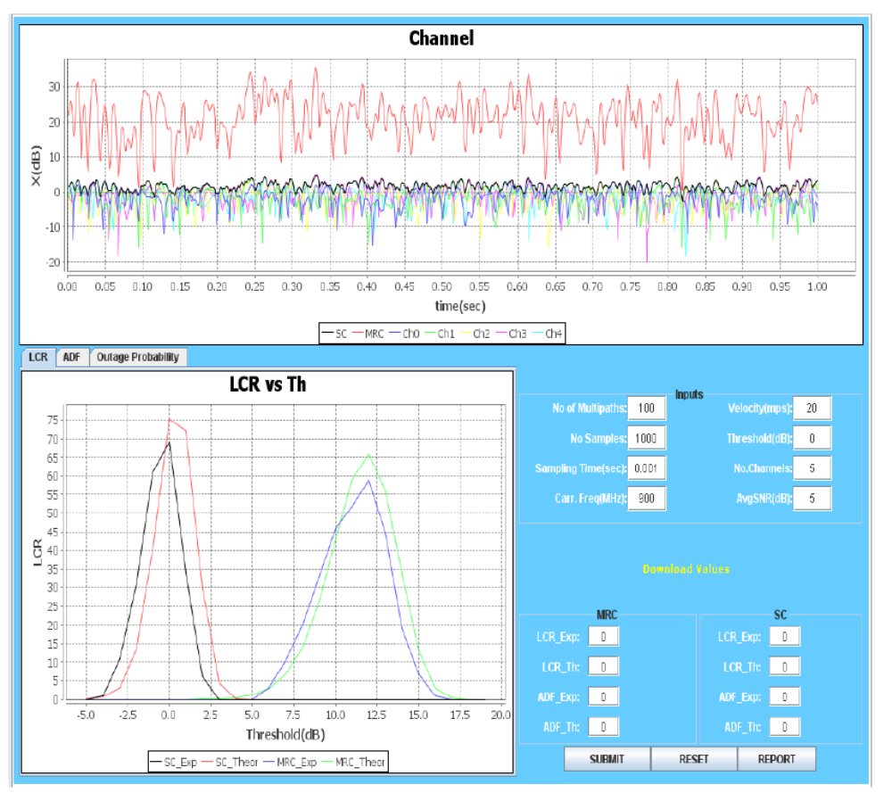

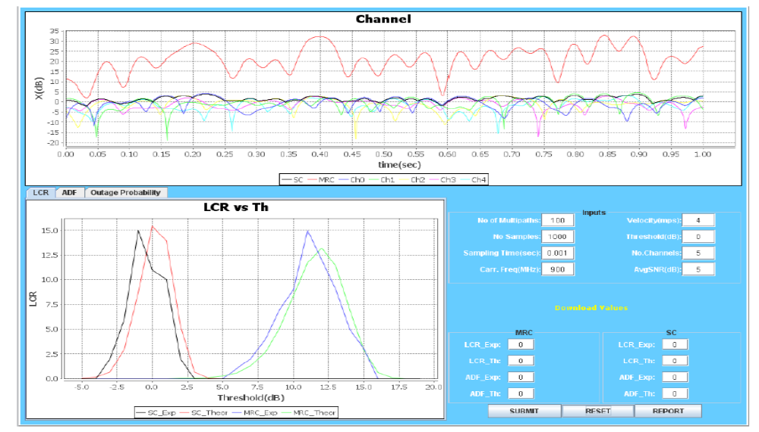

Step4: Enter value of LCR Exp and ADF Exp in both MRC and SC from the waveform. Then Click on "SUBMIT" Button.

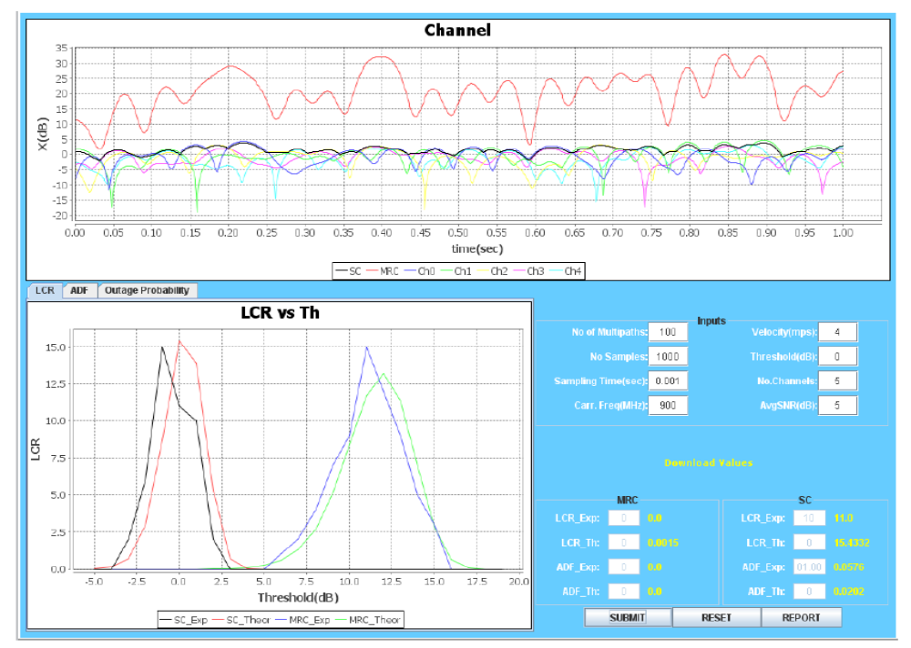

Step5: Click on REPORT to generate PDF report of the experiment.

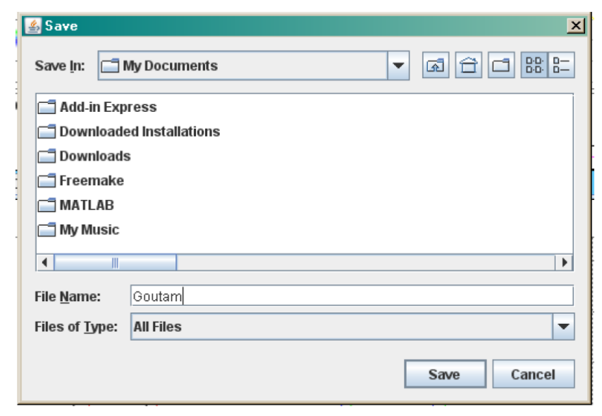

Step6: After generation of the report you will get following message
.

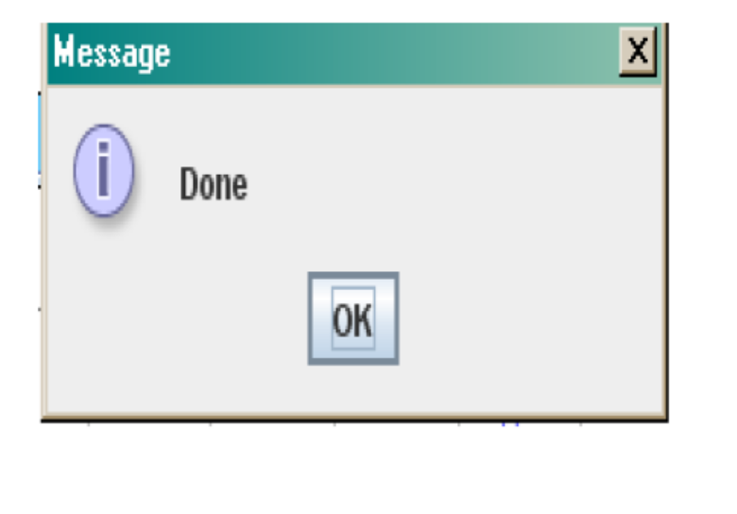

Step7: Click on the "Ok" and you will get your Report.
.
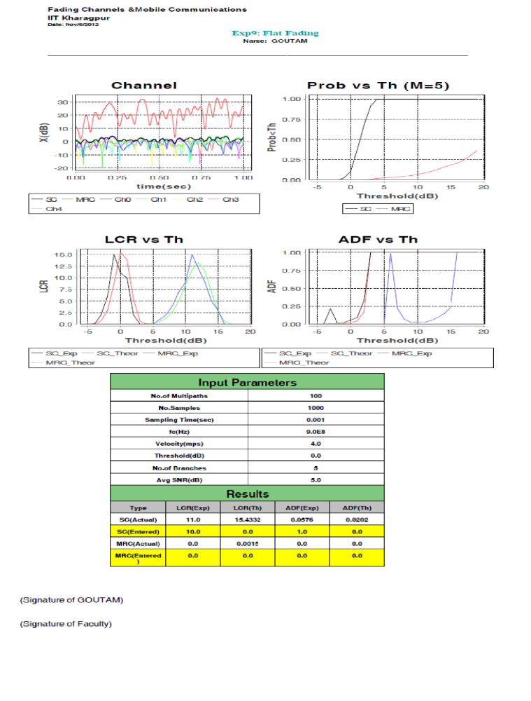

Step8: To redo the experiment, click on RESET button.

V. CONCLUSION:

SIGNATURE

REFERENCES:
1. “Wireless Communications--Principles and Practice” – Rappaport, T. S.
2. “Principles of Modern Wireless Communication Systems” – Jagannathan, A. K.

